Java SE Project

Training And Placement Application

***AdminHRModuleFrame Documentation***

1. **AdminHrModuleFrame -**

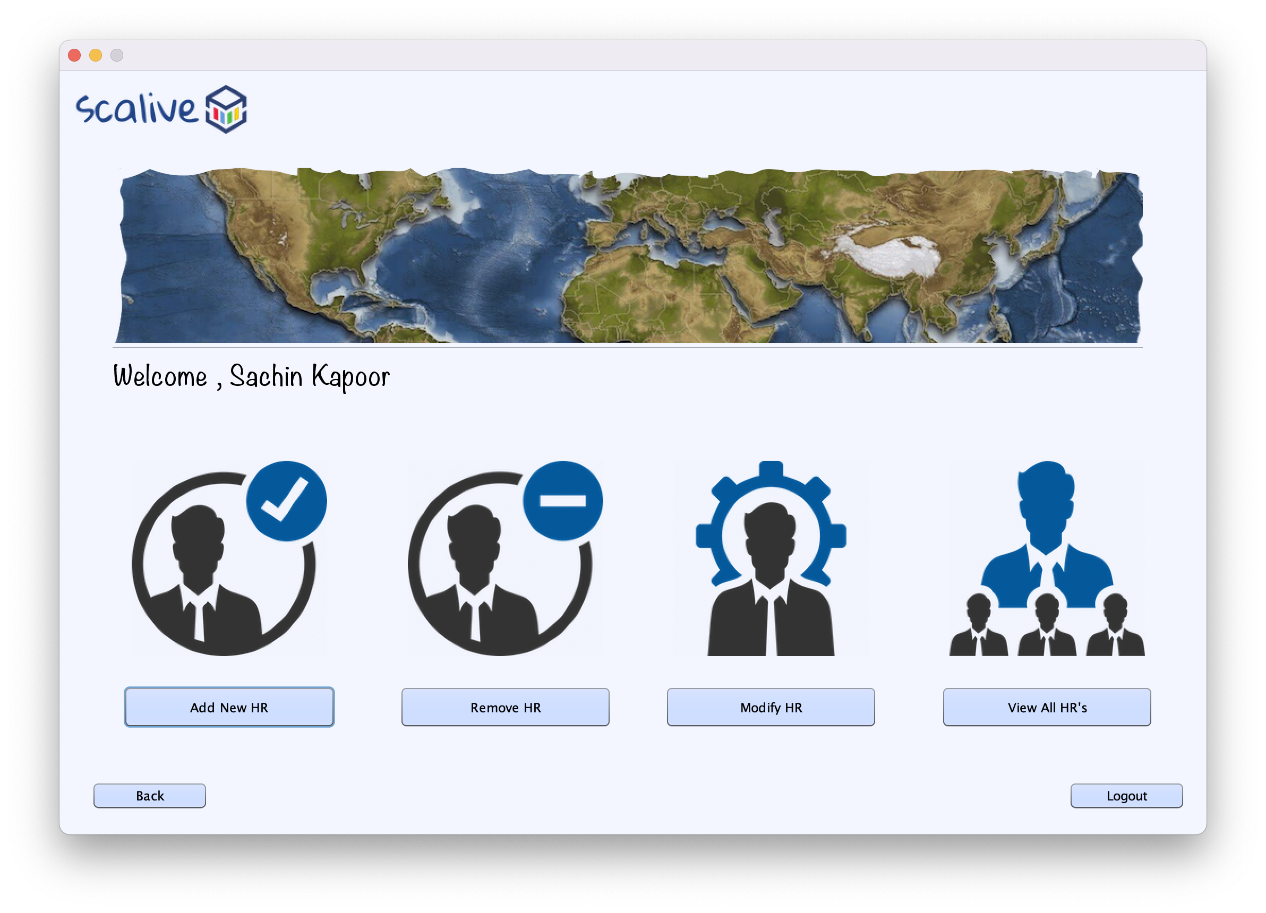

**2. STEPS TO BE DONE IN** **AdminHrModuleFrame**

In the **AdminHrModuleFrame** we need to do following steps:

A. Display **username**

B. Allow the user to **logout**

C. Allow the user to **go back**

D. Provide the following options:

**Add New HR**

**Remove HR**

**Modify HR**

**View All HR**

1. **Displaying The Username**

We can recall that we saved the **current user details**  in the static fields of the class **CurrentUser** . So in the constructor of **AdminOptionsFrame** we will call the **getName( )** method of the class **CurrentUser** to get the username and display it in the Label.

**public class AdminHrModuleFrame extends javax.swing.JFrame {**

**public AdminHrModuleFrame() {**

**initComponents();**

**this.setLocationRelativeTo(null);**

**lblName.setText(CurrentUser.getName());**

**}**

1. **Allowing The User To Logout**

To allow the user to logout , we will provide a button with the following functionality:

1. **When the user will click on the Button, the user will be logged out i.e. we will dispose the current frame and open the LoginFrame.**

**private void logOutBtnActionPerformed(java.awt.event.ActionEvent evt) {**

**new LoginFrame().setVisible(true);**

**this.dispose();**

**}**

1. **Allowing The User To Go Back**

To allow the user to go back, we will provide a button with the following functionality:

1. **When the user will click on the Button, the user will be moved to the previous frame which is AdminOptionsFrame i.e. we will dispose the current frame and open the AdminOptionsFrame.**

**private void btnBackActionPerformed(java.awt.event.ActionEvent evt) {**

**new AdminOptionsFrame().setVisible(true);**

**this.dispose();**

**}**

**D.Handling The Options**

The next task is to allow the user to click on the buttons amongst **Add New HR , Remove HR , Modify HR and View All HR**

To do this we need to handle the Buttons in the following way:

1. **When the button will be clicked actionPerformed of that specific button will be handled.**
2. **We will first create the object of next frame , make it visible and dispose the current frame**

**private void addNewHrBtnActionPerformed(java.awt.event.ActionEvent evt) {**

**new AdminAddNewHrFrame().setVisible(true);**

**this.dispose();**

**}**

**3. Next step -**

After Admin validation we have to shift on next frame i.e. **“AdminAddNewHrFrame”**